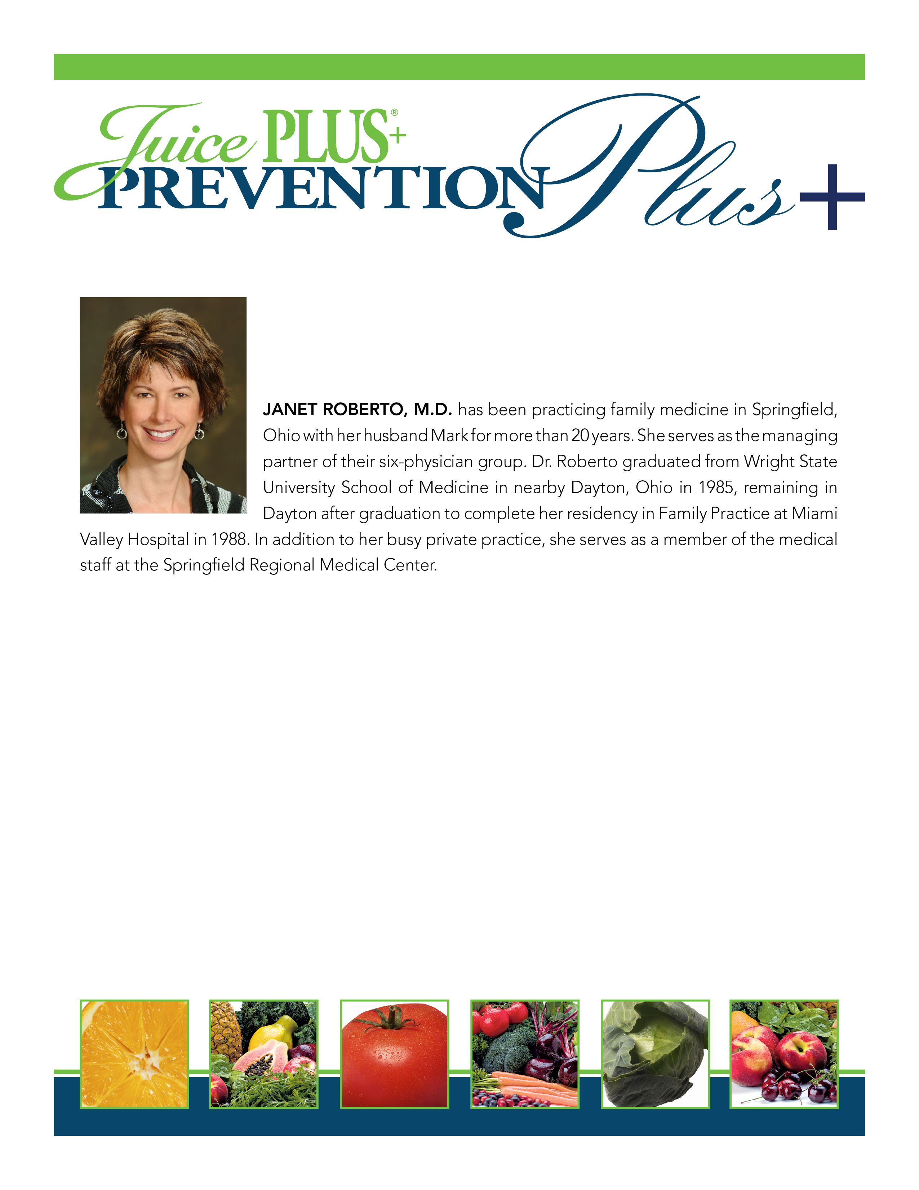

***Dr. Jan will share how to look and feel great while having the energy to be active and stay healthy!***

Thursday, February 21st, 2013 @7:30 pm

RSVP Banquet Center; 453 Wards Corner Road

Loveland, OH 45140

**My guests can attend for free.**

**Email Jenny at jenniferacombs@hotmail.com**

***Choose Vitality...***

***from the inside out***